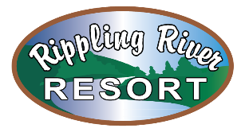
NOW HIRING!

-The Role-
Rippling River Resort is looking for a hard-working, enthusiastic Housekeeper to join our team. The incumbent is responsible for cleaning and maintaining all cabins, bathhouses, lodge and property grounds throughout the Resort.
-Responsibilities-
The incumbent is responsible for:
- Cleaning all cabins before and after guest use. This includes changing linens/making beds, cleaning bathrooms, kitchen area, vacuuming/sweeping, cleaning up trash and more duties as needed.
- Cleaning all bathhouses
- Cleaning up garbage and debris around the property
- More duties as assigned
-Minimum Qualifications-
- Must be a minimum of 18 years of age
- Must hold a valid Driver’s License
- Weekends required
- Must be computer literate

